PROJECT PROPSAL



GROUP MEMBERS: UM-E-AQSA & FAIZA ILYAS.

COURSE NAME: Database. Systems

COURSE INCHARGE: Ms. Samia Gazala

PROJECT: E-SHOPPING SYSTEM

DEPARTMENT COMPUTER SCIENCE

AND SOFTWARE ENGINNERING

**E-SHOPPING SYSTEM**

1. **ABSTRACT/OBJECTIVES**

* As we are beginners and have no practical experience in the field of software development and moreover the E-SHOPPING SYSTEM is very wide. So, we limit the scope of our project by computerizing the following fields of the e-shopping System. The operations performed by this project are maintenance the information of the Customers that are shopping from our site. This project is mainly dealing with the order taking and providing invoice by using cart, customer and product id.
* Purchasing product.
* Adding products to cart.
* Generating invoice
* Admin maintaining customer information

1. **SCOPE**

* It is very difficult to do shop physically in current situation of covid by online or e shopping we can just order our things online and they will deliver our products at doorsteps thIS project also enables us to do online shopping and manages all the records of customer order and products electronically in more reliable way.
* The scope of this project is very wide because we are talking about e-shopping and now a days e-commerce plays vital role in today's world

1. **DESCRIPTION:**

ER diagram is known as entity –relationship diagram. It shows the relationship between entities and their attributes.

Er diagram of bank has the following description:

* + An e-shopping system have many branches in itself .
  + This whole system consists four main entities customer, products, carts, invoice, admin, location
  + Customer are identified by Address, contact, email, phone, name, customer_id and address
  + A Customer purchase product and add it to cart and then it generates invoice
  + At the time or delivery product can be identified by customer_id, product_id, cart_id.
  + A customer request for products and it to carts
  + All details of customer are maintained by admin.
  + Customer purchases products.
  + Products contain product name, product_id, product price, c-date and mod-date
  + Customer can add products in carts.
  + Carts contain c-date, mod-date, total products, products name, number of products, id and price

**Entities:**

* Customer
* products
* cart
* invoice
* admin
* location

**ATTRIBUTES:**

Attributes are:

* Customers contains name, address, customer_id,c-date, mod-date, email,postcode
* Products contains product_id, product_name, price, c-date, mod-date
* Carts contains cart_id , c-date, mode-date, total, product_name, number of products, id, price
* Incoice contains product_id, customer_id, cart_id.
* Admin contains id, mod-date, address, customer name, c-date
* Location contains customer name and id

**DRAFT ERD:**

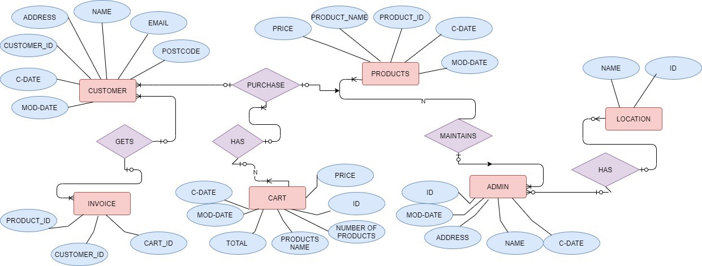

**SCHEMA TABLE**

**CUSTOMER**

|  |  |  |  |  |  |  |
| --- | --- | --- | --- | --- | --- | --- |
| **CUSTOMER_ID** | **CUSTOMER_NAME** | **ADDRESS** | **EMAIL** | **POSTCODE** | **C-DATE** | **MOD-DATE** |

**PRODUCT**

|  |  |  |  |  |
| --- | --- | --- | --- | --- |
| PRICE | PRODUCT_NAME | PRODUCT_ID | C-DATE | MOS-DATE |

Shape

**CART**

|  |  |  |  |  |  |
| --- | --- | --- | --- | --- | --- |
| CART_ID | NUMBER_OF_PRODUCTS | TOTAL | PRICE | C-DATE | MOD-DATE |

**INVOICE**

|  |  |  |
| --- | --- | --- |
| CUSTOMER_ID | PRODUCT_ID | CART_ID |

**ADMIN**

|  |  |  |  |  |
| --- | --- | --- | --- | --- |
| CUSTOMER_ID | CUSTOMER_NAME | ADDRESS | C-DATE | MOD-DATE |



**LOCATION**

|  |  |
| --- | --- |
| **NAME** | **ID** |